|  |  |  |
| --- | --- | --- |
| **NAME** | **:** | **MUCHAMMAD NABIL HAYKAL WIDARTO** |
| **CLASS** | **:** | **SIB-1G** |
| **NIM** | **:** | **2341760152** |

<https://github.com/muchnabil/daspro-jobsheet8>

**Assignment Jobsheet 8**

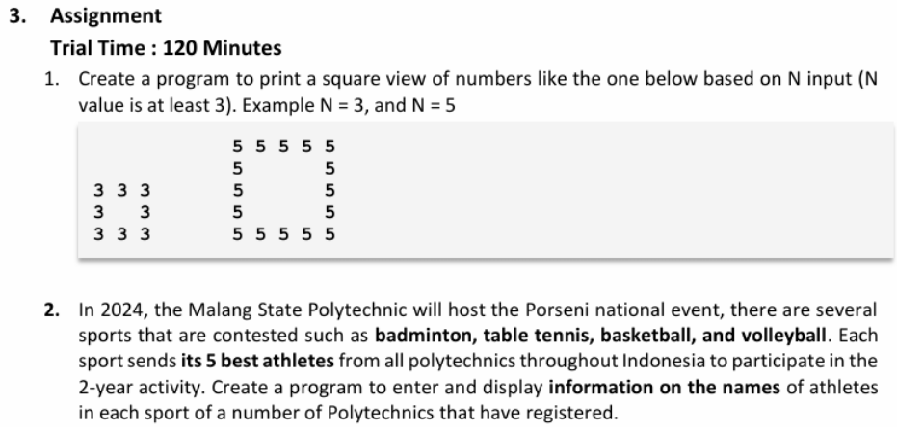

Answer :

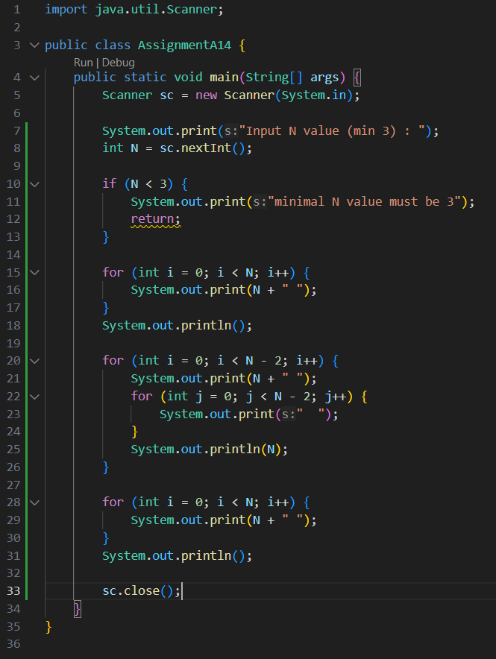

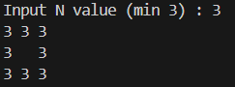 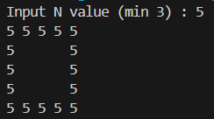

2. 